**Name : Hemalatha Karumuri**

**Date : 13/12/23**

**Question:1 => Querying Data by Using Joins and Subqueries**

**1)Creating a database called assessment and table to perform joins**

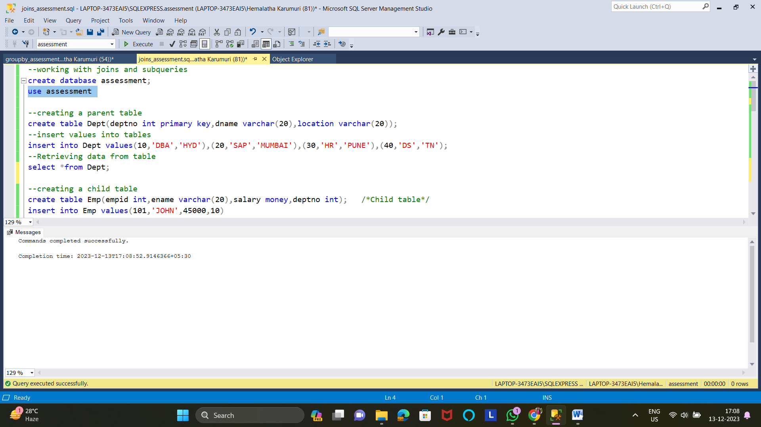

**2)inserting values in to the table Dept**



**3)creating a child table**

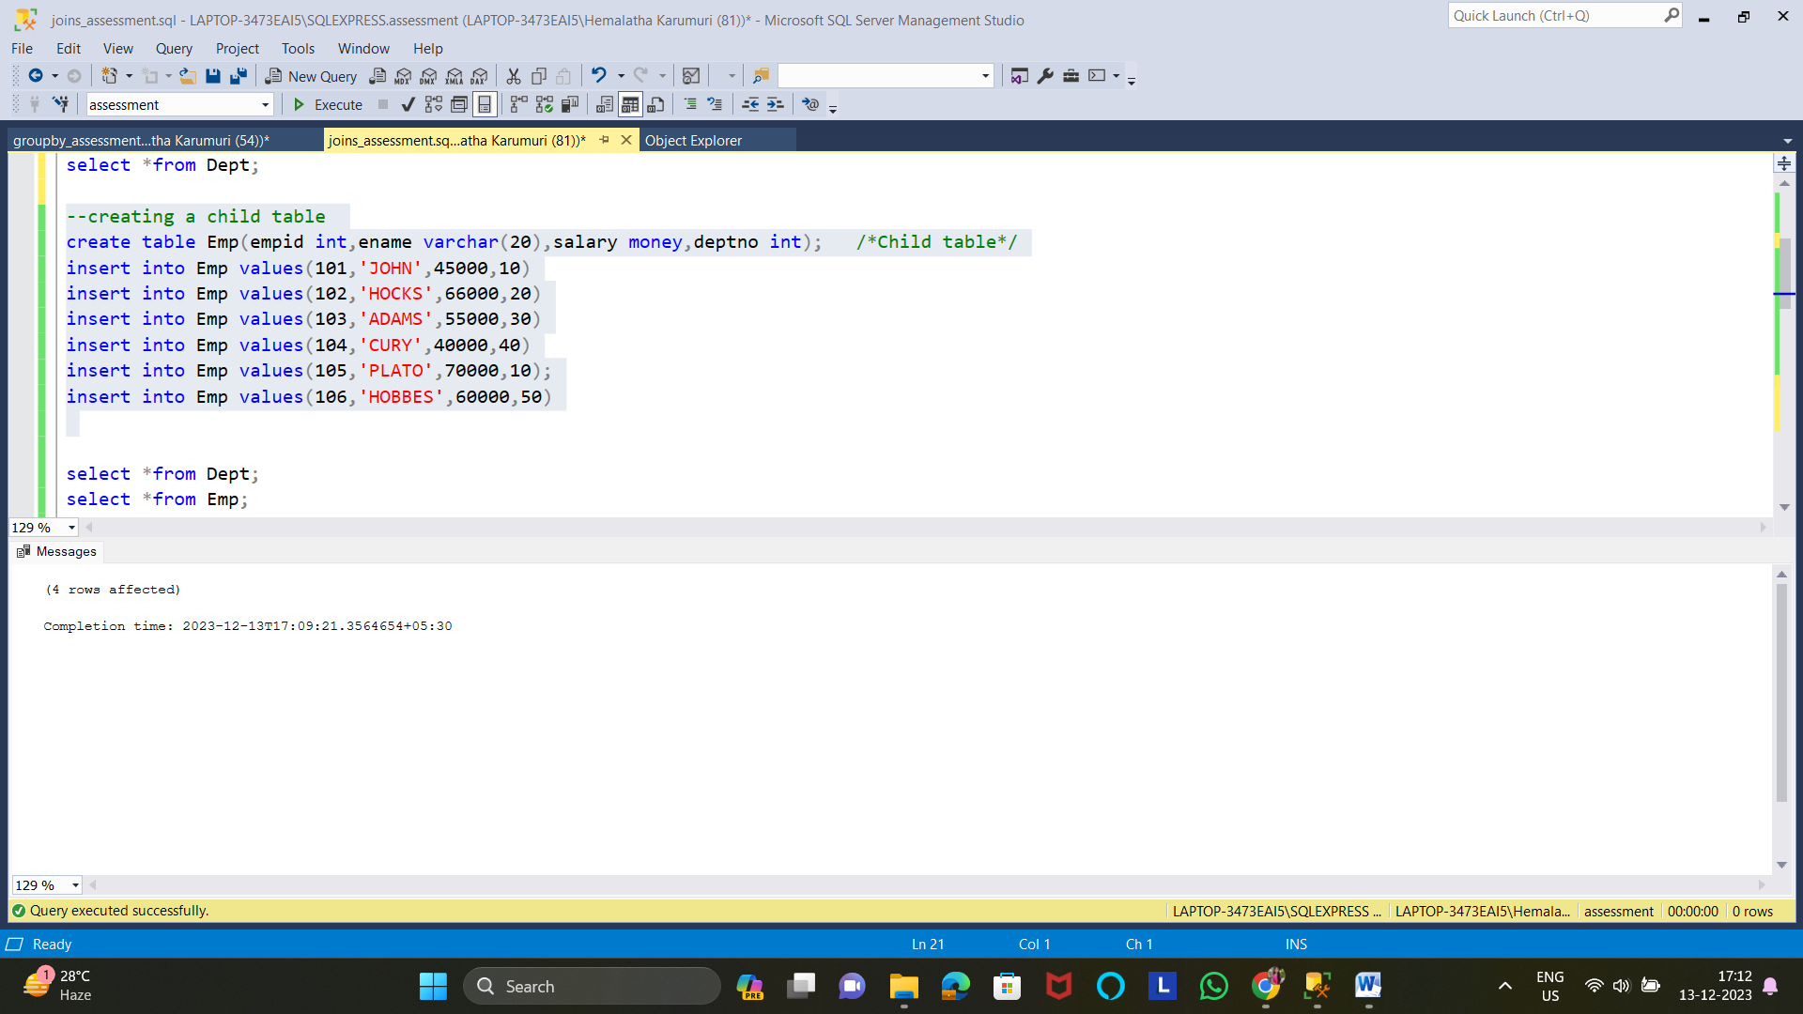

**4)Data from both the tables**

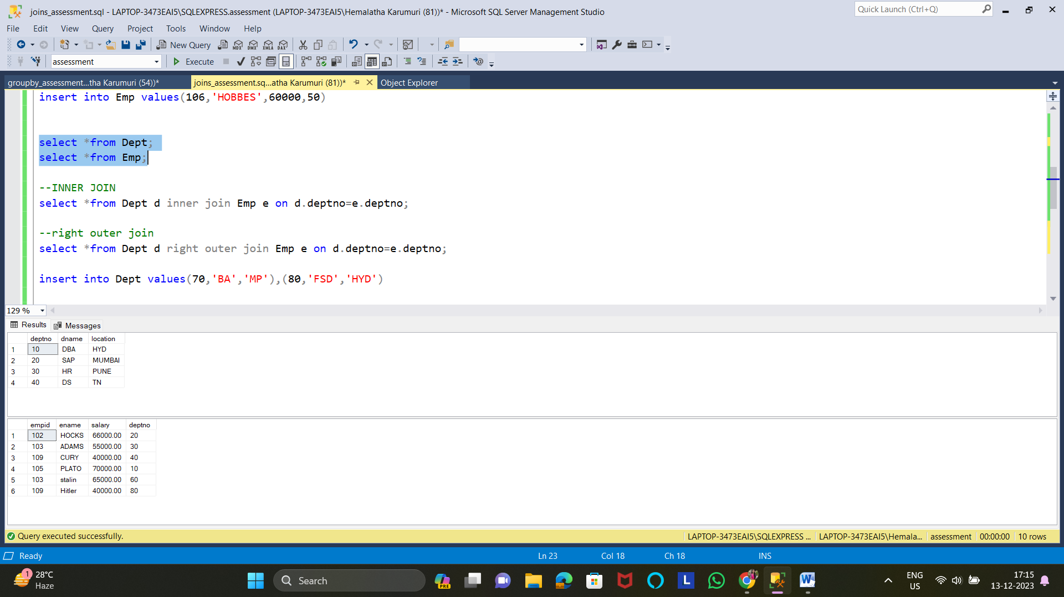

**5)performing inner join**

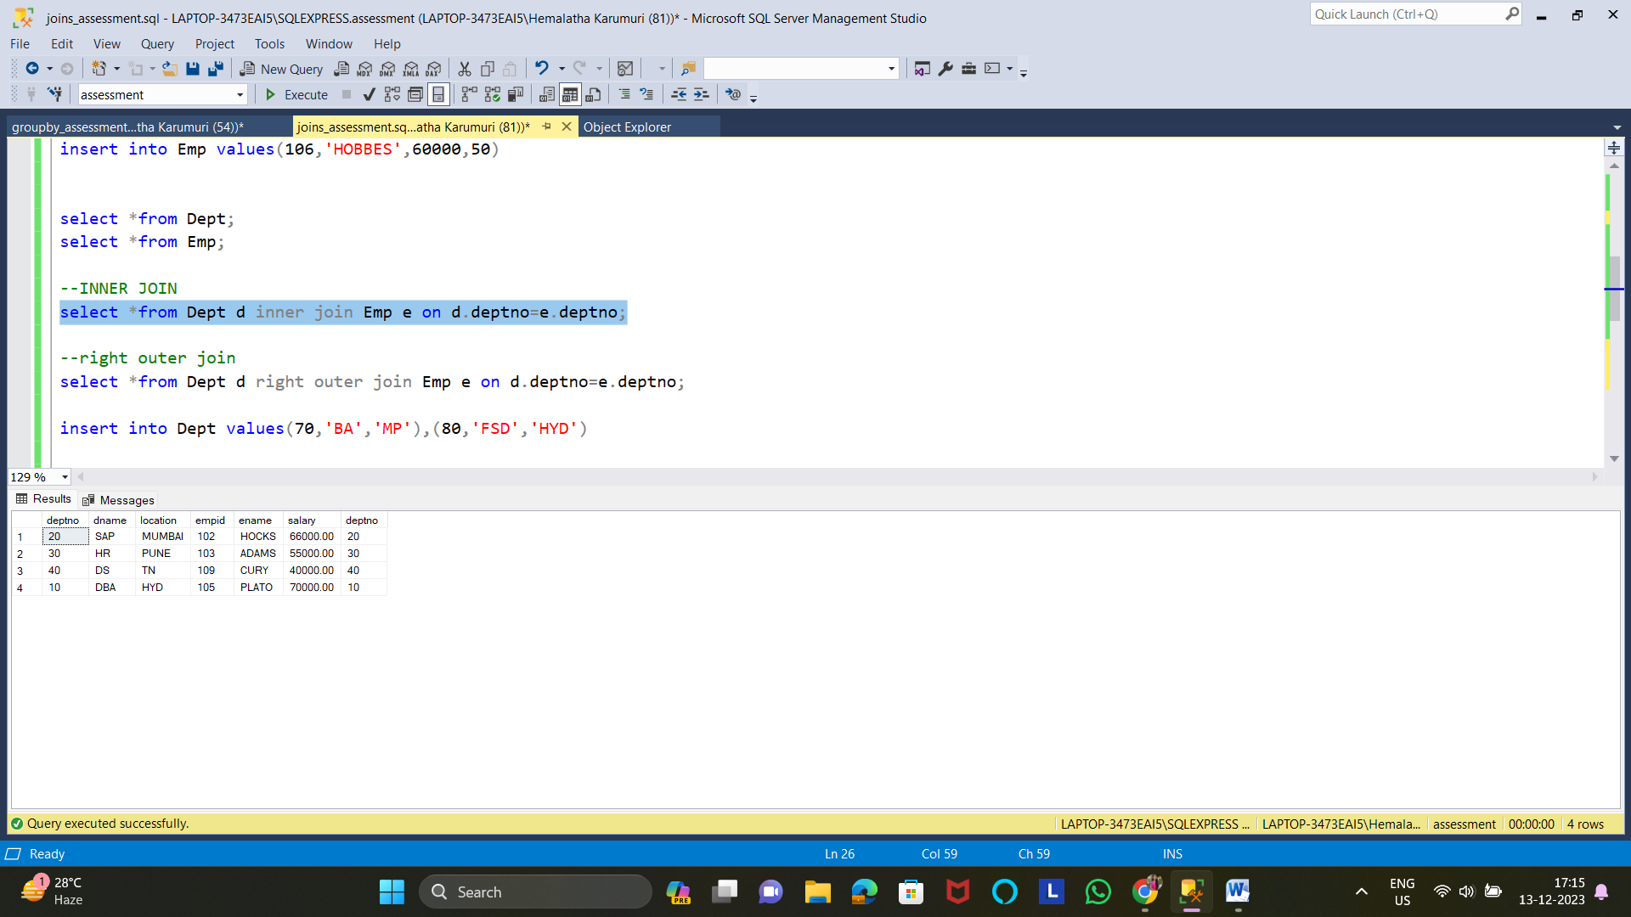

**6) performing right outer join**

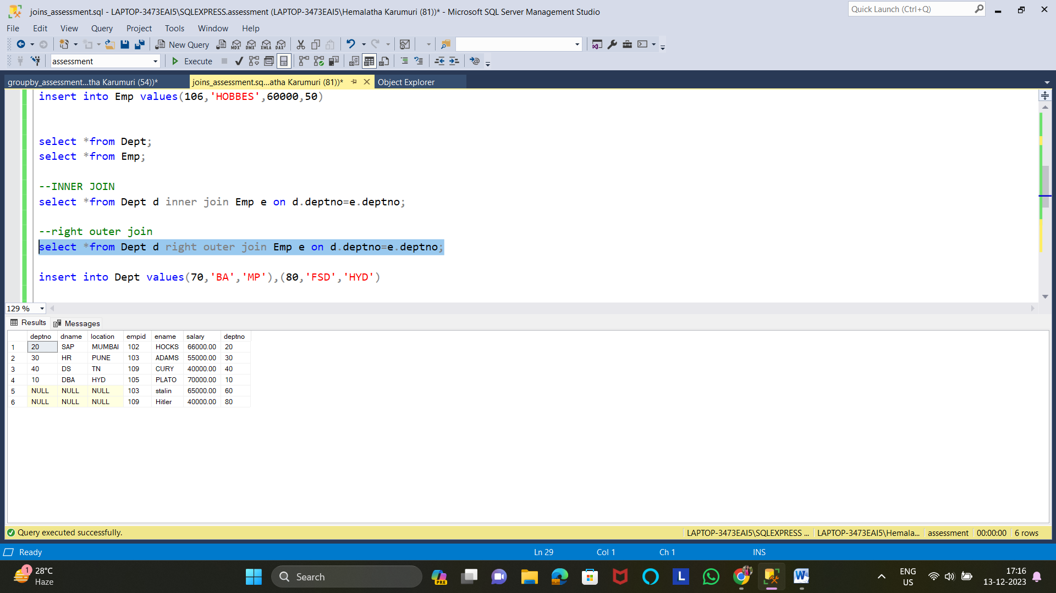

**7) performing left outer join**

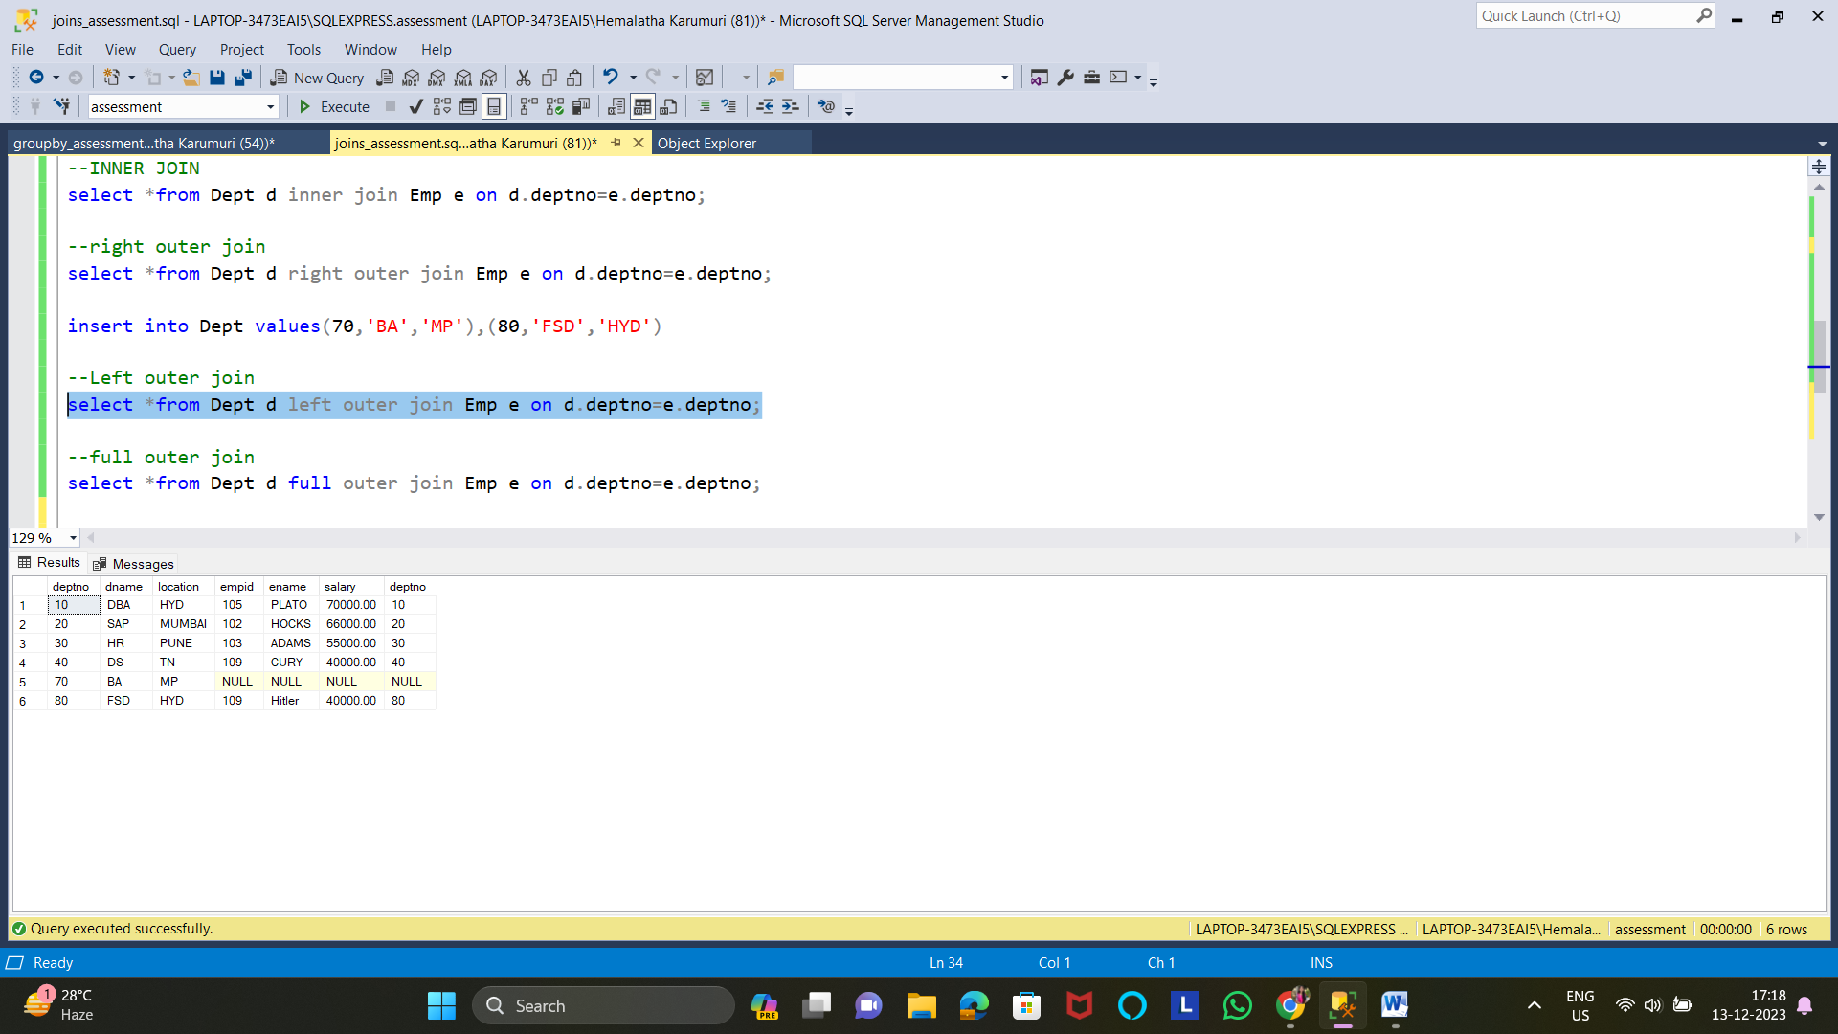

**8) performing full outer join**

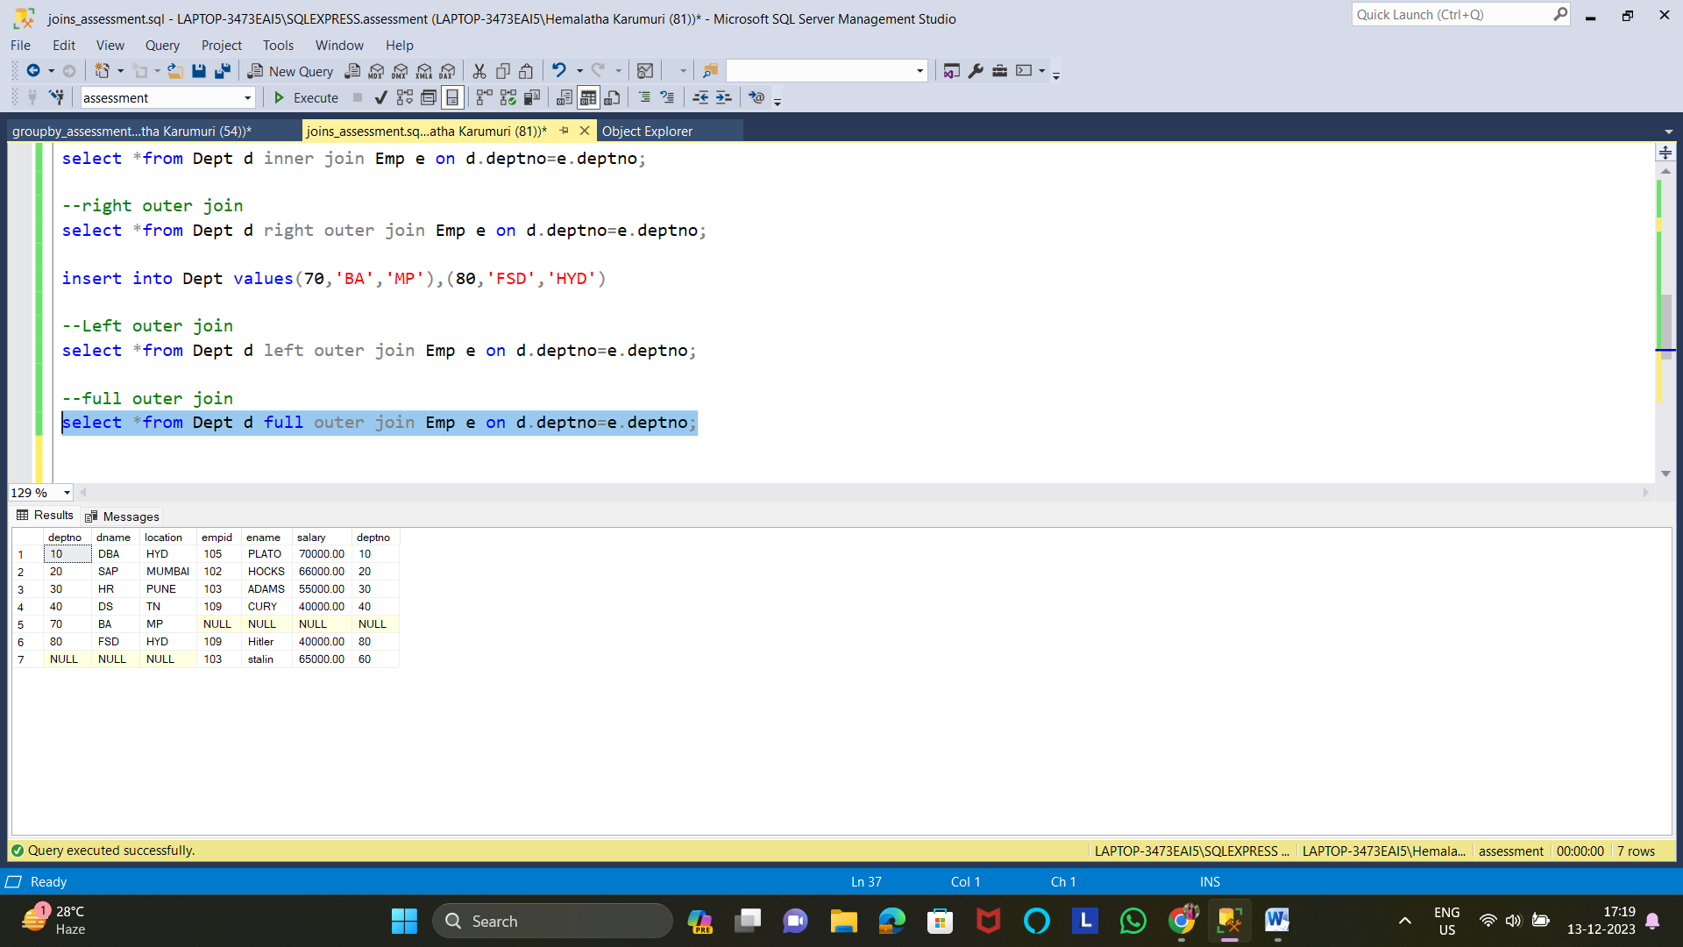

**9)Executing all the subqueries**

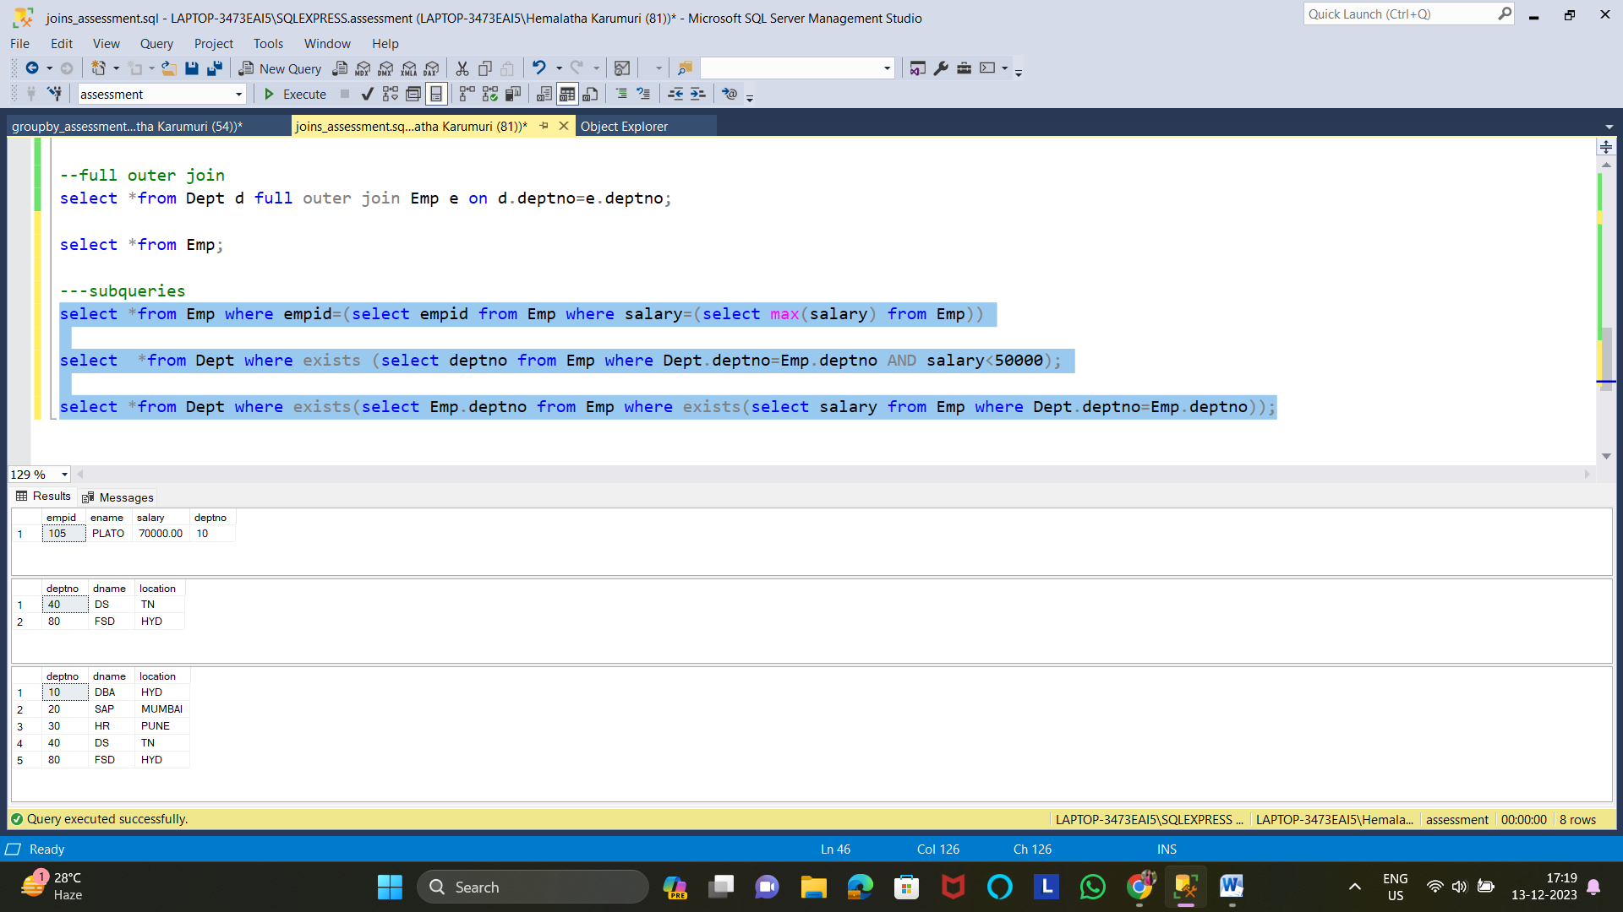

**Question 2: Manipulate data by using sql commands using groupby and having clause.**

**1)Using the database assessment and table Emp**

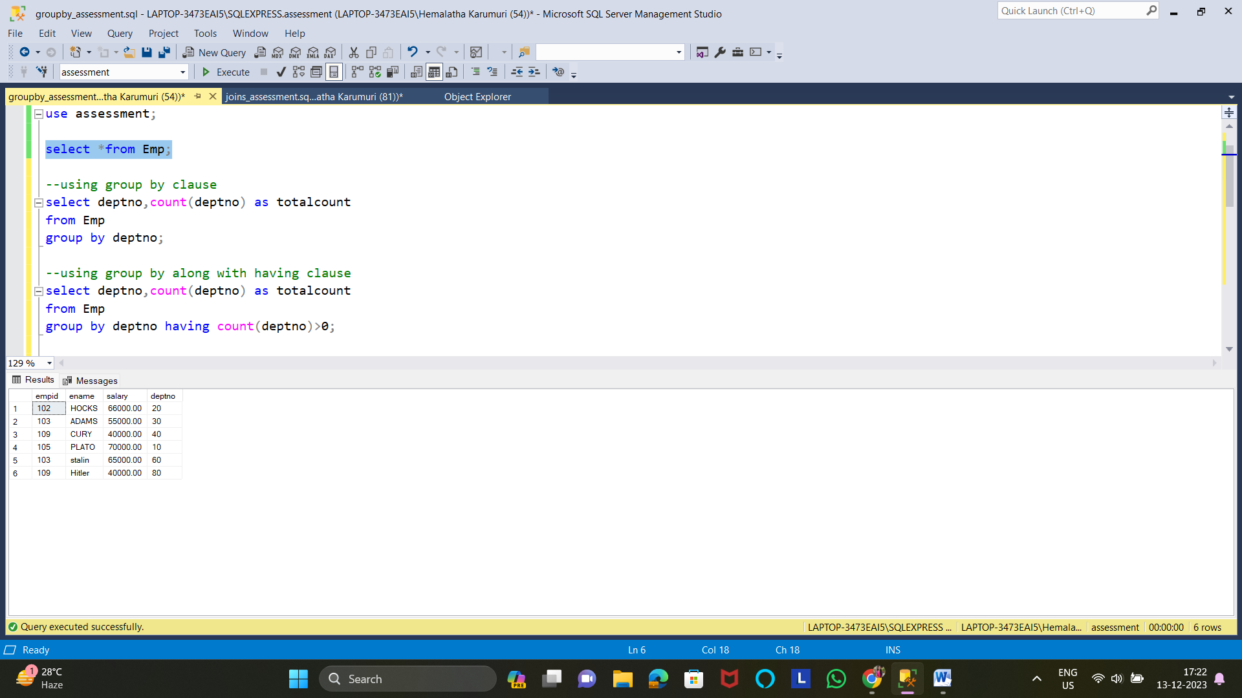

**2)Using group by clause**

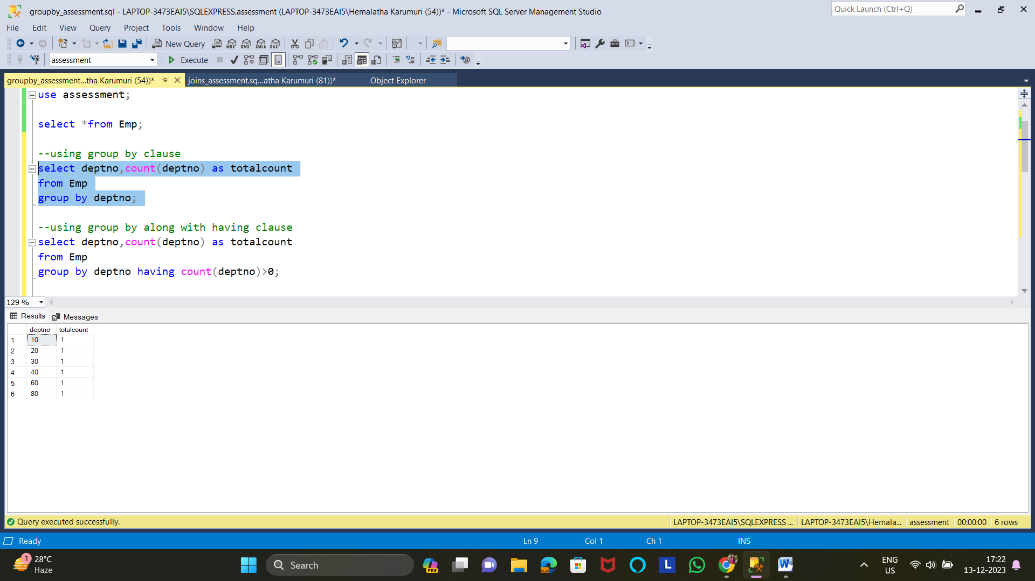

**3)using group by clause along with having clause**

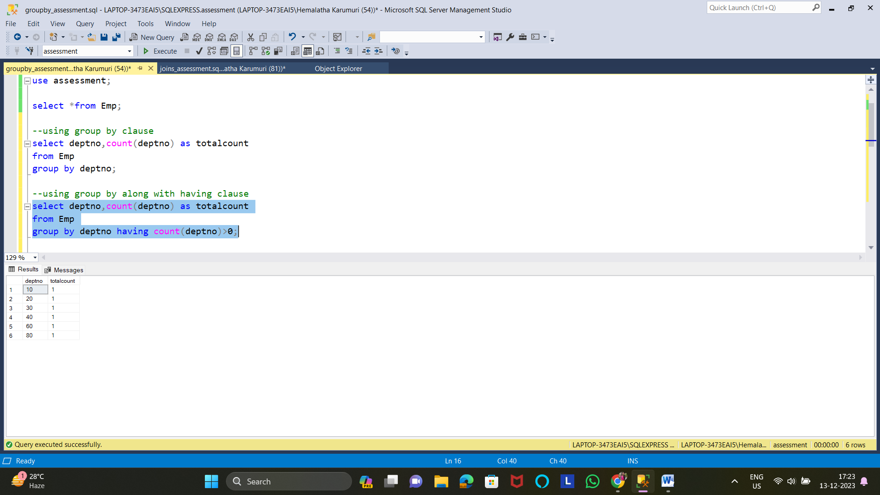

**4)Data manipulation using select statement**

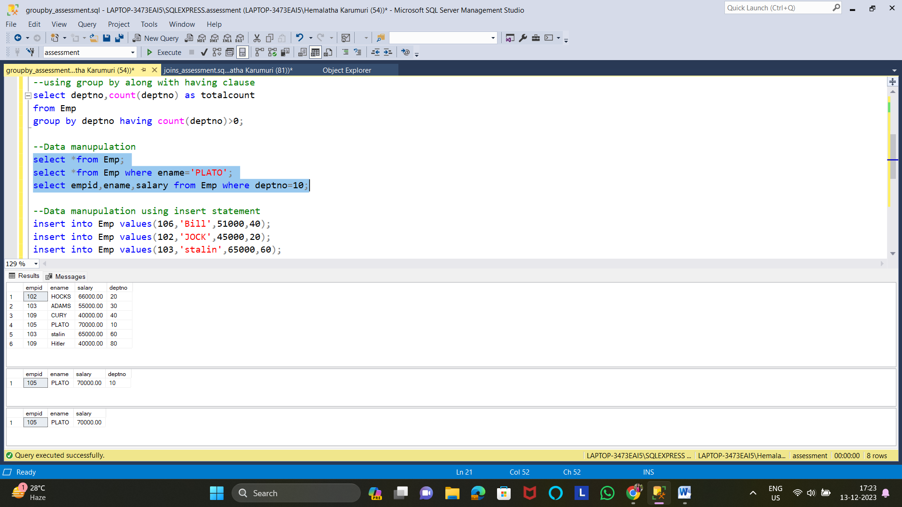

**5) Data manipulation using insert statement**

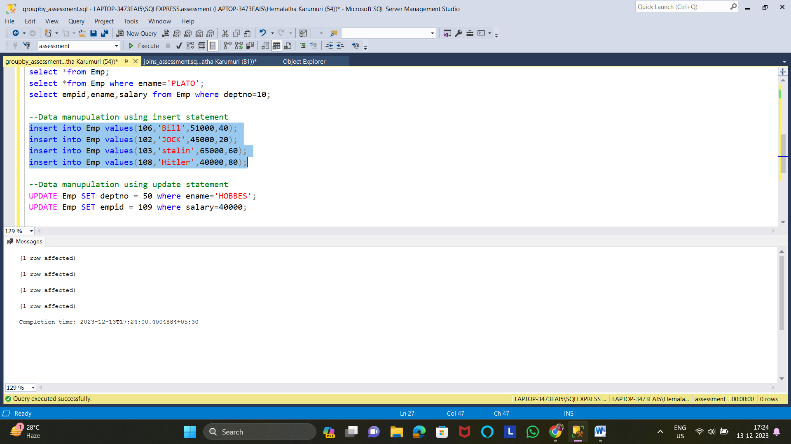

**6) Data manipulation using update statement** 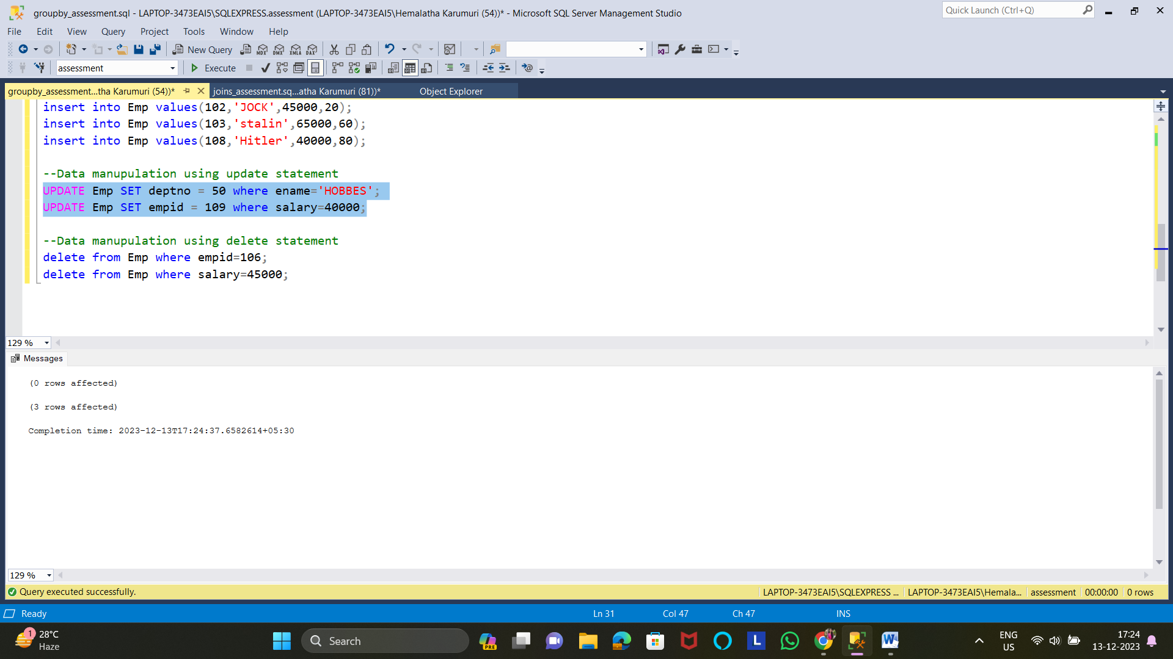

**7) Data manipulation using delete statement**

